**Introduction**

Add equipment page in the WPS page to enhance features as similar to MonitPro application. This will be nice feature as this will bring in standardization of equipment and bring in data visualization, which will be added in the near future to the WPS.

**Add Equipment page**

Develop the page as below:

Add all the items but Template and Format Number is not required and the rest everything is required.

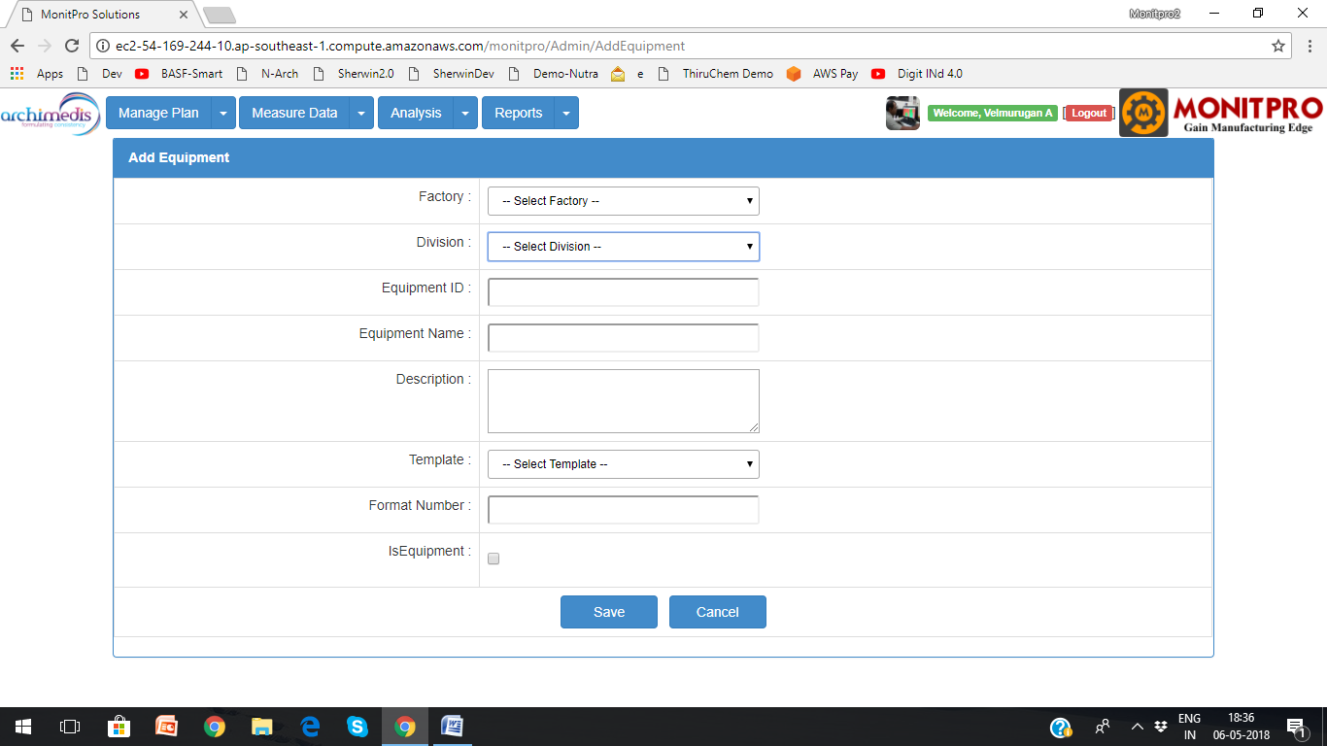

**Equipment list**

Develop the page as below

Add all the items except format number; newly created Scan option will not be required

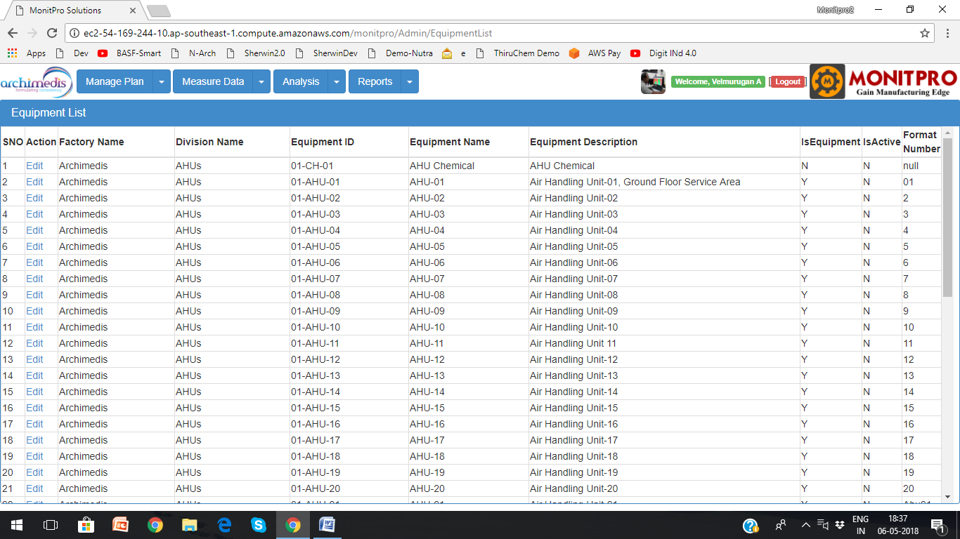

**Create/Edit Privilege**

Show the two tabs for the person with approver privileges (only) to add/edit and modify.

**Which Tab?**

Add these two pages in the Create Permit Tab

**How it will link with Permit section?**

In the create permit pate, Equipment section will have dropdown rather than free text.

**Other modifications to other pages (future)**

In closed permit list, we might add Equipment list search option (filter option); Type of work as well in the future.